Analogue Signal Processing SOLUTIONS

Special instructions for students
Unless otherwise stated the following parameters have the following definitions:
V_{DS} : Drain Source Voltage.
V_{GS} : Gate Source Voltage.
V_{TH} : Threshold Voltage.
U_{t} : Thermal Voltage.
n : Weak Inversion Slope factor.
g_{m}: Transconductance.

  - State two advantages and two disadvantages of encoding analogue signals in time rather than amplitude.
Advantages:
- Supply independence
- Spike domain coding can be event driven resulting in low power (triggers processing) [2 points]
Disadvantages
- Specialised circuits are required for encoding.
- Data is quantised in time, and therefore susceptible to phase noise. [2 points]
[4]
  - Draw a circuit which encodes a current mode signal in a domain which is continuous time but discrete in amplitude, and explain it’s operation deriving equations of the relationship between the input and output signals and time domain plots of how the amplitude of an analogue signal is encoded.
Axon Hillock circuit:
Circuit Diagram and explanation of operation (4 points)
Equations (2 points)
Time domain plot (2points)

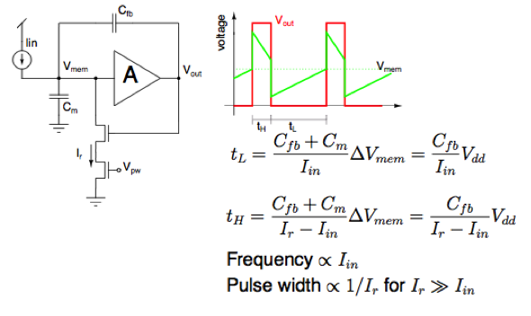 [8]
  - For the cascade of amplifiers shown in Figure 1.1, derive the output referred noise and explain what factors can be optimized to reduce this and optimize signal to noise ratio.
Mos Noise: 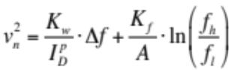
Distributed gain: 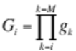
Total output Noise: 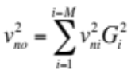
Final Equation: 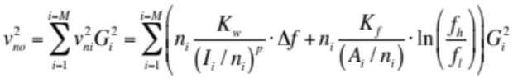 [6 points]
• Increasing Power and Area reduce the noise
• If we are willing to compute slowly (Δf and fh/fl are both small) then we can keep output noise low without consuming a lot of power. [2 points]

[8]

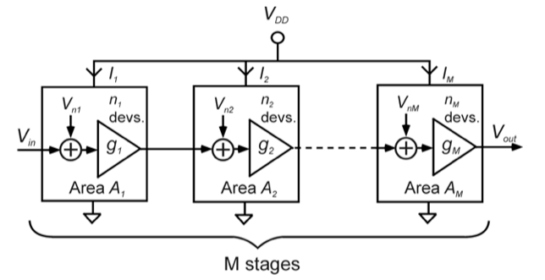

Figure 1.1

  - Explain why MOSFETs operating in weak-inversion make suitable translinear elements and state two limitations when using these in translinear circuits that may apply specifically to weak inversion operation.
[bookwork]
MOSFETs in weak inversion have an exponential relationship between VGS and IDS. The tranconductance is therefore linear with VGS. Through the logarithmic relationship we can therefore multiply currents in a KVL loop. [2]

Drawbacks:
Currents need to be limited to below 100nA. [1]
Temperatures must be equal to get rid of thermal voltage terms. [1]
[4]
  - Figure 2.1 shows a translinear circuit.

- Derive the function of the circuit using the tranlinear principle. I_{z} is the output and I_{x} is the input.
Squaring Circuit from notes:
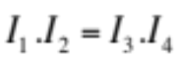 and therefore 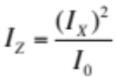 Total 2 points.
[2]
- Show how with the addition of a few transistors the circuit can be modified to calculate the function 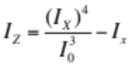
New circuit derivation:
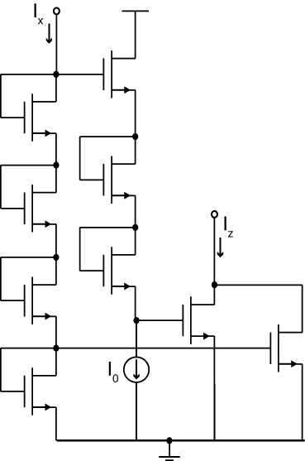 Total 5 points.
[5]
- A capacitor is added between the point A on the circuit in Figure 2.1 and ground. Derive the new transfer funcion of the circuit stating the gain and time constant. The final equation of the transfer function should be represented in the s-domain.
Derivation from theory:
Capacitor current:
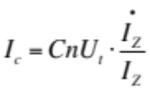
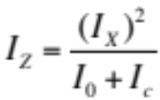
Combining:
$$I_{z}=\frac{I_{x}^{2}}{I_{o}+CnU_{t} .\frac{\dot{I_{z}}}{I_{z}}}$$
$$I_{z}I_{o}+CnU_{t} .\dot{I_{z}}=I_{x}^{2}$$
Taking laplace transform:
$$I_{z}I_{o}+CnU_{t} .sI_{z}=I_{x}^{2}$$
$$I_{z}(I_{o}+CnU_{t} .s)=I_{x}^{2}$$
$$I_{z}=\frac{I_{x}^{2} }{I_{o}+CnU_{t} .s}=\frac{I_{x}^{2} /I_{0}}{1+CnU_{t} .s/I_{0}}$$
[3 points]
Gain = $I_{x}^{2} /I_{0}$ [1 point]
Time constant: $τ=CnU_{t} /I_{0}$ [1 point]

[Total 5 points]
  - The equation for calculating the harmonic mean of a signal is given as:

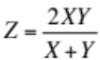

Show how this equation can be re-arranged to design and implement the translinear circuit shown in Figure 2.2 deriving also the out current Iz.

Derivation from notes:

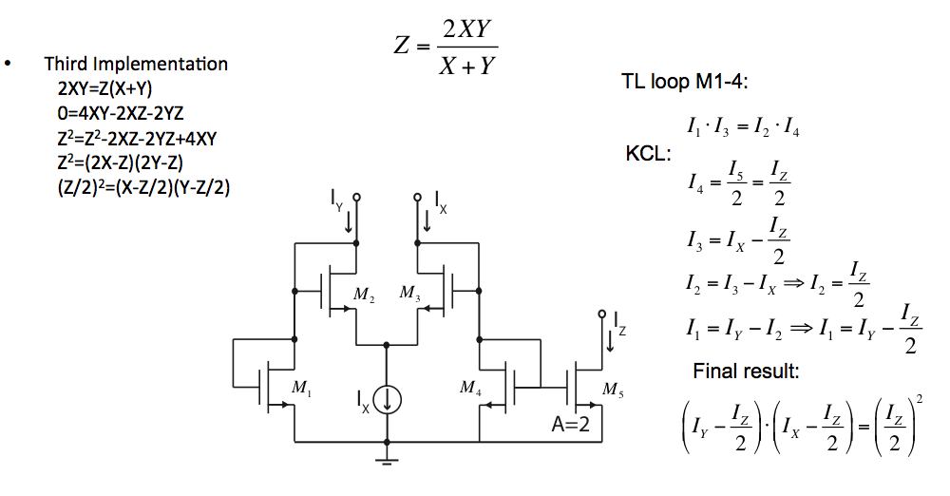
1 point for break down of equation
3 points for derivation of transfer function.

[Total 4 points]

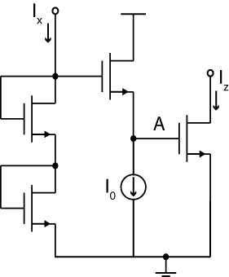

Figure 2.1
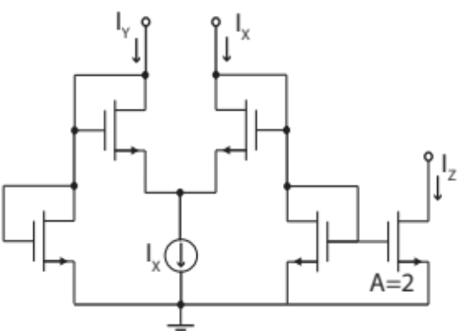
Figure 2.2
- The transfer function of a second order topology has been decomposed into the following state-space equations:
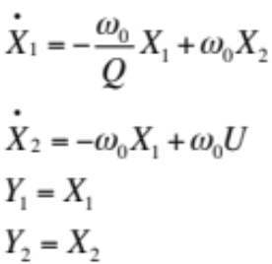

whereby Y₁ and Y₂ are the outputs and X₁ and X₂ are the state-variables and U is the inputs.

- Show that the output Y₁ can be used to implement a second order lowpass transfer function whereas the output Y₂ can be used to implement a “two-pole one-zero” second order transfer function.
New derivation:
$$\left[s+\frac{ω_{0}}{Q}\right]X_{1}\left(s\right)-ω_{0}X_{2}\left(s\right)=0$$
$$ω_{0}X_{1}\left(s\right)+sX_{2}\left(s\right)=ω_{0}U\left(s\right)$$
Substituting for X₂(s) (2 points)
$$\frac{Y_{1}\left(s\right)}{U\left(s\right)}=\frac{X_{1}\left(s\right)}{U\left(s\right)}=\frac{ω_{0}^{2}}{s^{2}+\left(\frac{ω_{0}}{Q}\right)s+ω_{0}^{2}} , low pass response$$
Substituting for X₁(s) (2 points)
$$\frac{Y_{2}\left(s\right)}{U\left(s\right)}=\frac{X_{2}\left(s\right)}{U\left(s\right)}=\frac{ω_{0}^{} \left(s+ \frac{ω_{0}}{Q}\right)}{s^{2}+\left(\frac{ω_{0}}{Q}\right)s+ω_{0}^{2}} , two pole ,one zero response$$

[Total 4 points]

- By using the mappings below show how these linear equations can be mapped to non-linear log-domain design equations. State any assumptions you make.

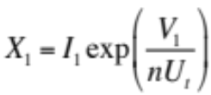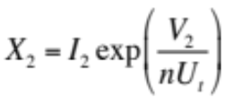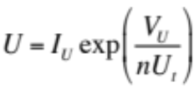

New derivation from Theroy:
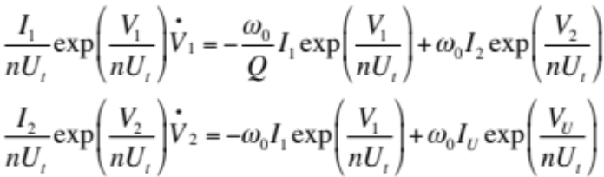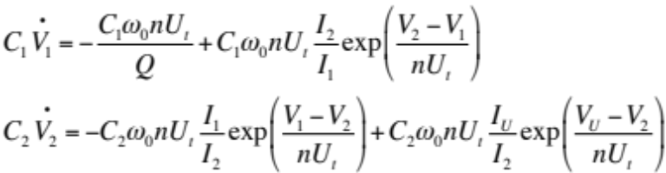
Let C1=C2=C and define 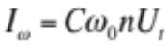

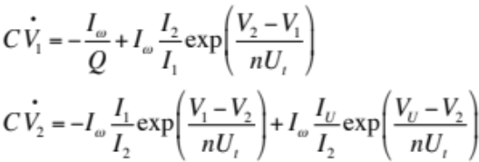
A suitable mapping:
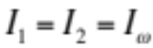
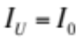
Final equations:
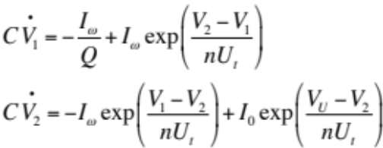
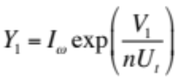
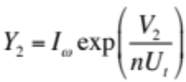
Total 6 points

- With these log-domain design equations, sketch a schematic of the final log domain topology which realises the two outputs Y1 and Y2 using weak inversion MOS transistors.
A Solution using the above equations:

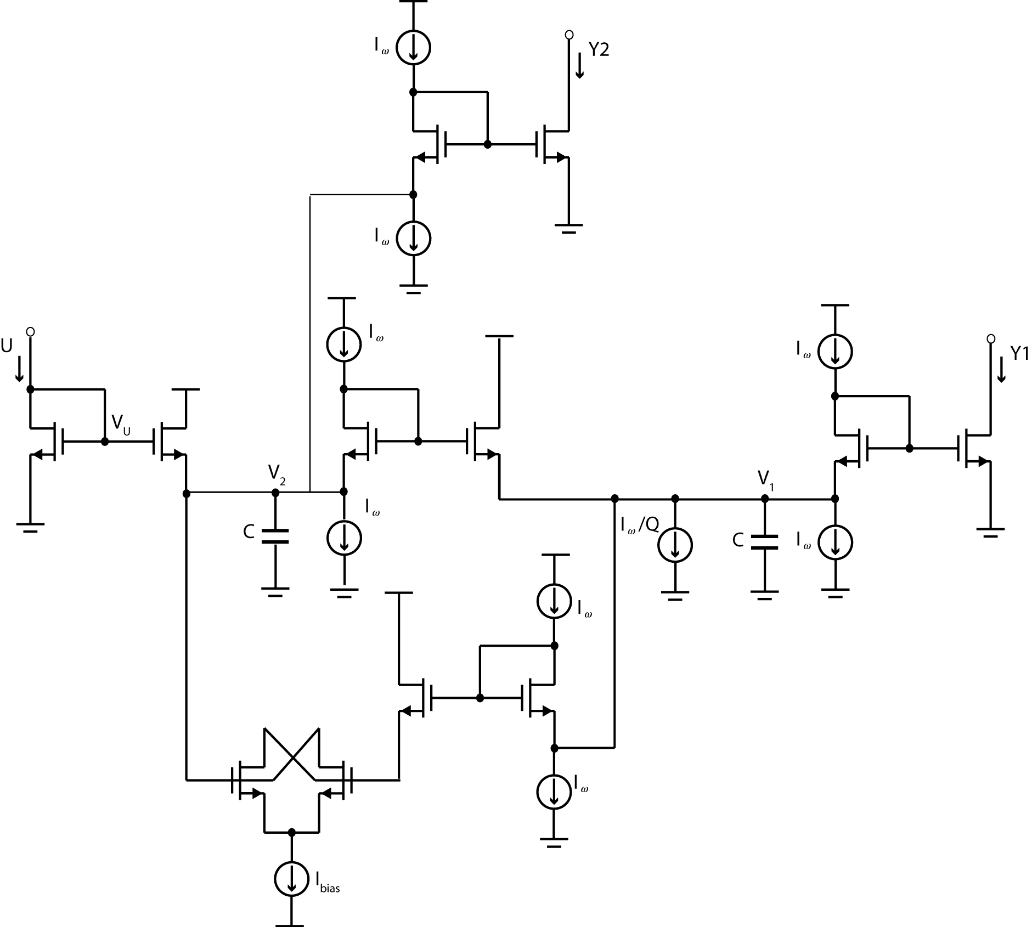
[Total 8 points]

- Given the low pass biquad filter has cut-off frequency, f₀ = 4KHz, select a suitable current for I_{ω} given that the filter capacitor is C = 10 pf , n = 1.23 and U_{t} = 25mV.
I_{ω} =10pf x 2π x 4KHz x 1.23 x 25mV =7.7nA
[Total 2 points]
- Figure 4.1 depicts a switched current memory cell.

  - State two limitations of the circuit shown in figure 4.1 and draw an improved schematic which compensates for these.

The switched current memory cell is susceptible to mismatch between the two transistors in addition to the drain source voltage variations between the sampling and readout phases which will cause an error in the output current. Increasing the output impedance through cascoding reduces the dependency of I_{D} on V_{DS}. This is achieved using a regulated cascode: [2]

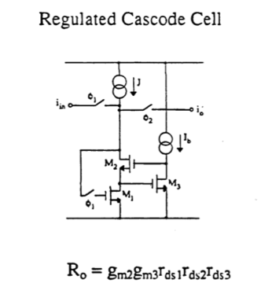 [2]
[Total 4 points]

  - Using your schematic from part 4.a.i, design a unit delay cell proving a z⁻¹ function and derive the equation for its operation.

New circuit based on taught theory:
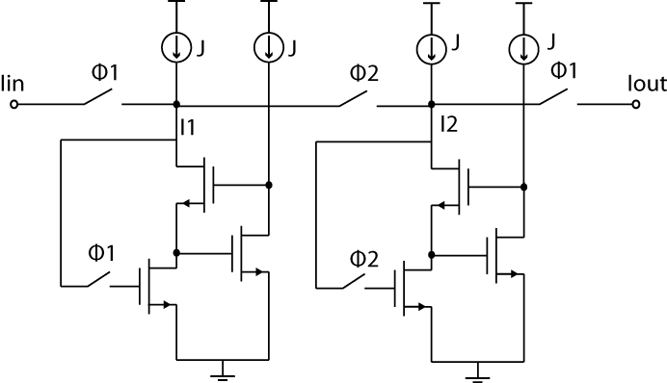[3]

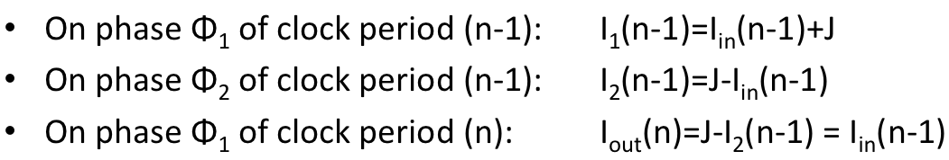[1]
[Total 4 points]

  - Figure 4.2 depicts an FIR filter architecture. Using your unit delay cell from part 4.a.i, sketch a full circuit schematic which implements this function. You may assume the current is unidirectional and use only pmos current mirrors to copy the current.

New circuit based on taught theory:

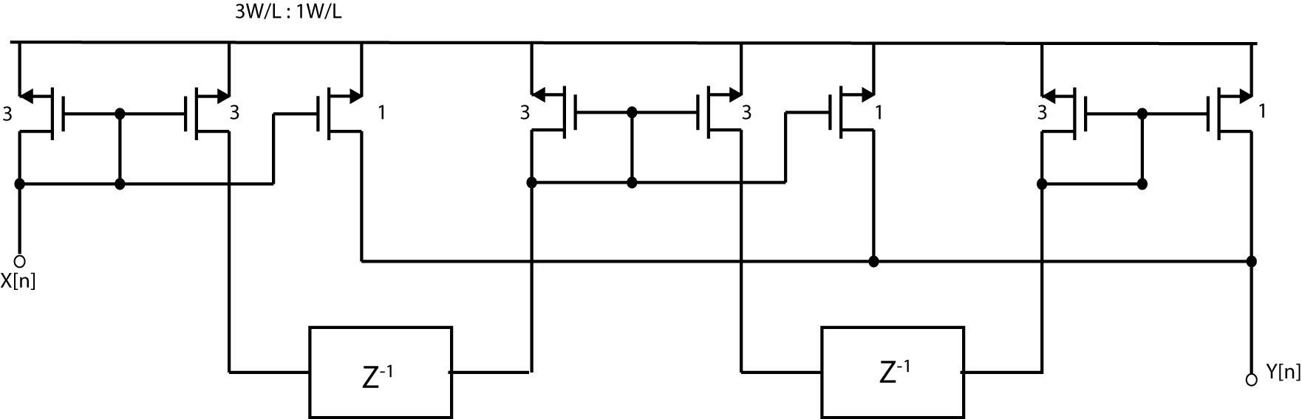
[Total 6 points]

  - What is the role of the circuit in Figure 4.2 ?

The circuit computes a moving average over 3 samples.
[Total 2 points]

  - Figure 4.3 shows a schematic of switched current integrator. Derive the transfer function of the switched current integrator and show that in the z-domain this may be represented as H(z) = A/(z-1).

Derivation from lecture notes:
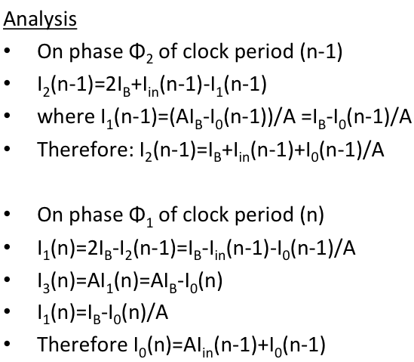

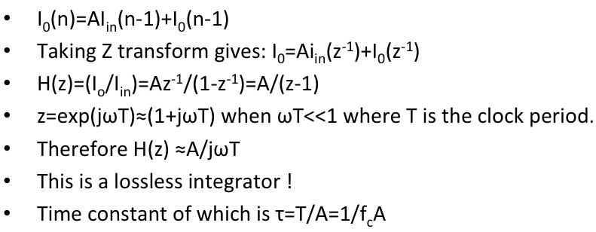 [Total 4 points]

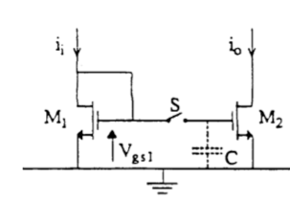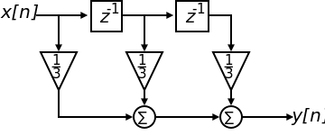

Figure 4.1 Figure 4.2
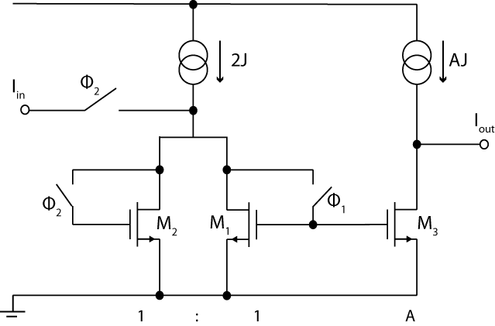
Figure 4.3
5. Figure 5.1 shows a multistage autozeroing amplifier.

- Explain how this amplifier conducts an autozeroing operation to remove any offsets in the amplifier cascade, showing timing diagrams of switches and deriving the voltages V₁ and V₂ and the voltages across the capacitors C₁ and C₂ for each clock phase. You may use only three stages in your explanation
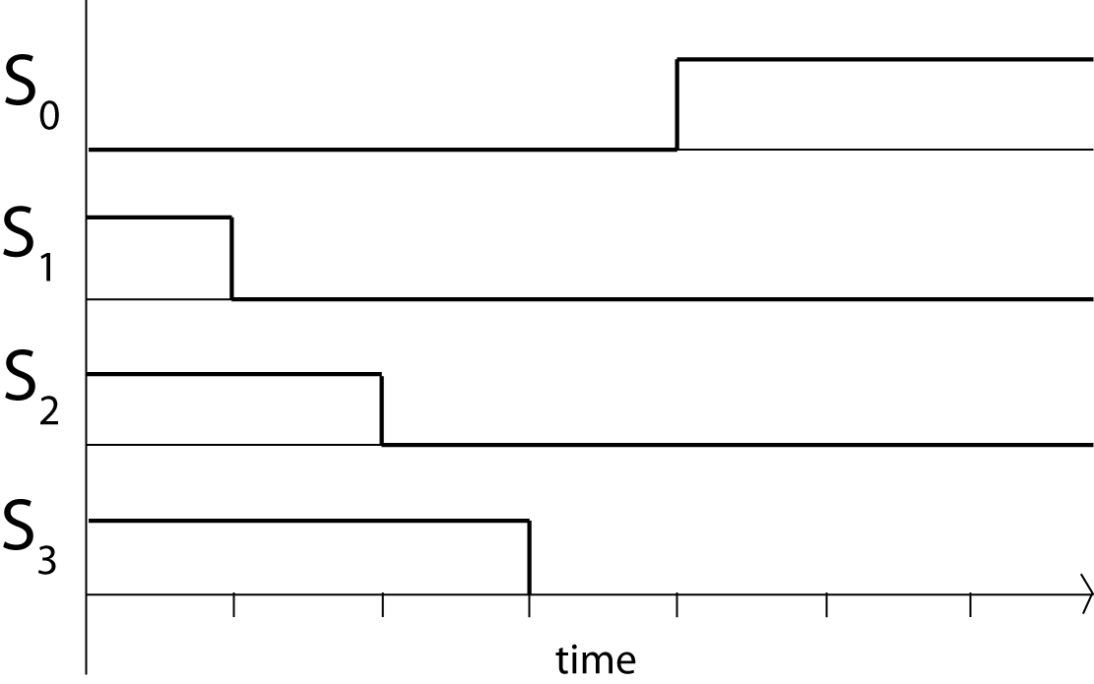
Graph showing clock and switch timing. Need to show progressive opening of switches S1-S3 for each clock period. [2]

Sampling phase:
- S₀ is connected to ground and all amplifiers connected as unity gain feedback stages.
- Voltage across capacitor C₁ : V_{c1}=A₁(V_{os1}-V_{c1})=A₁V_{os1}/(A₁+1) [2]

Amplifying phase:
- S₁ is released first, thus charge injection due to S₁ is stored on C₁.
- V_{c1}=A₁V_{os1}/(A₁+1) + q_{inj}/C₁
- V₁=A₁(V_{os1} -V_{c1})=V_{os1}+ A₁q_{inj}/C₁
- Charge Q₂ =C₂(V₁-V_{os2}A₂/(1+A₂)).
- Then sequentially S₂ is released.
- V₂=A₂ (V_{os2}-(V₁-Q₂/C₂-q_{inj}/C₂))=V_{os2}+A₂q_{inj}/C₂
- Neither offset nor charge injection of preceding stage propagates !
- Output offset is only affected by last stage offset and charge injection
- Output offset = V_{osN}+A_{N}q_{inj}/C_{N}
[4]
[Total 8 points]

- Derive an equation for the input referred offset , V_{os-res} for your cascade of amplifiers in Figure 5.1.

Input referred offset is thus:
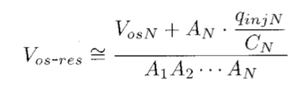[Total 2 points]

- For your derivation in part a.ii , assuming a three stage cascade of autozeroing amplifiers, each with a gain A=100 and an offset V_{os}=50mV, calculate the value of the storage capacitor, C₁=C₂=C₃, such that the total input referred offset V_{os-res} <100μV. You may assume that a charge of q_{inj}=6x10⁻¹² C is inserted each time the switch closes.
Substitute values into Vos-res:
100uV=(50mV+(100x6x10⁻¹²)/C)/100x100x100
Rearranging gives C=6 pF.
[Total 2 points]

- For a generic operational amplifier, desribe a technique which allows detection of very small voltage signals which exist below the 1/f noise floor of the ampifier. Include diagrams showing the operation of this technique and how the frequency spectrum of the signal and noise is shaped in each stage.

Theory from notes. Need to explain with diagrams how 1/f noise is upmodulated the removed by low pass filtering.
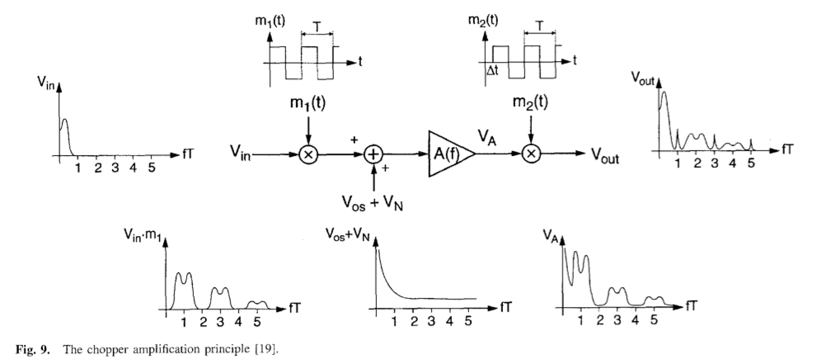
[Total 5 points]
- Sketch a circuit of which implements the method used in part 5.d to provide amplification using discrete op-amps.

Circuit from notes
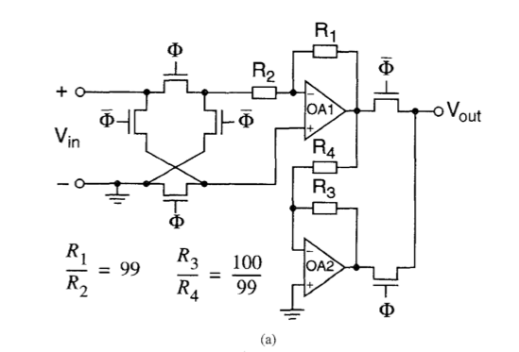
[Total 3 points]

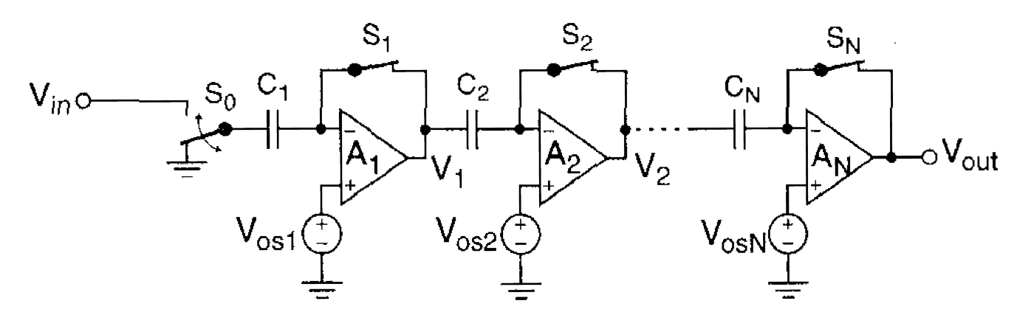

Figure 5.1

6.
- Sketch the block level architecture of a fully implantable cochlear prosthesis chip and explain the functions of each of the blocks shown in your figure.
From notes:
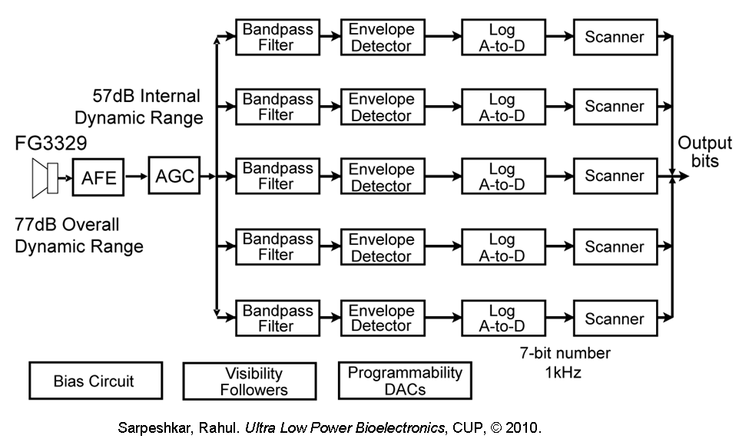[5]
- The Audio Front End (AFE) feeds audio signals to the Automatic Gain Control (AGC) circuit which compresses 80dB of audio to a 60dB electrical signal.
- The output of the AGC is fed to a bank of sixteen spectral-analysis channels that span the audio spectrum.
- Each channel consists of:
  - A band pass filter for that frequency.
  - A envelope detector to extract the spectral energy.
  - A logarithmic ADC to logarithmically compress the spectral energy to 7 bits.
  - A scanner which loads the parallel bits onto a serial bus to be sent to stimulator.
  - A stimulator which works based on continuous interleaved sampling (CIS) [5]

[Total 10 points]

- Figure 6.1 shows and automatic gain control system (AGC) typically used in cochlear prosthesis. The rectifier uses a current conveyor to convert the voltage V_{out} to a rectified current. The signals which follow are all based on current mode operation. The translinear controller implements a square root operation $y=\sqrt{x}$ . Sketch the full circuit schematic of the AGC stating assumptions where necessary. The varible gain amplifier does not need a transistor level schematic.
A connection of the following blocks from the notes:
Variable gain amplfier: [2]
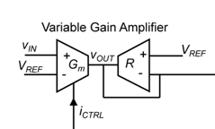
Rectifier: [2]
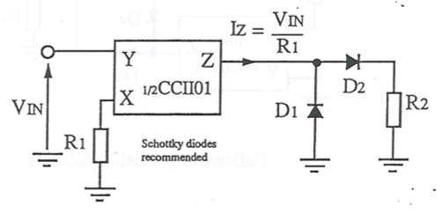
Peak detector: [2]
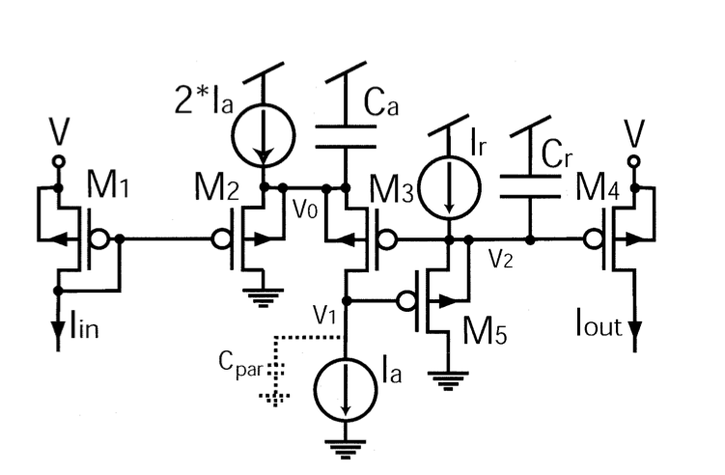
Square root operator: [2]
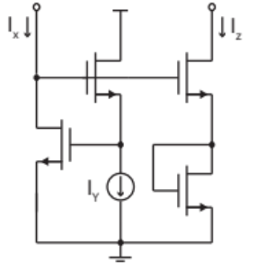
Minimum Circuit: [2]
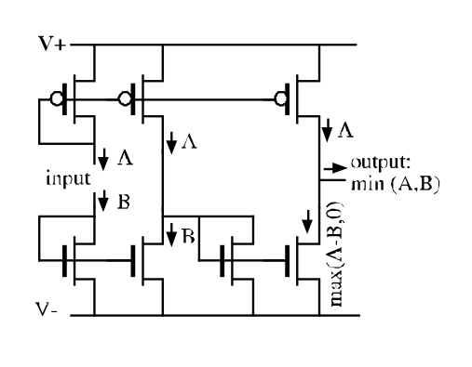
[Total 10 points]

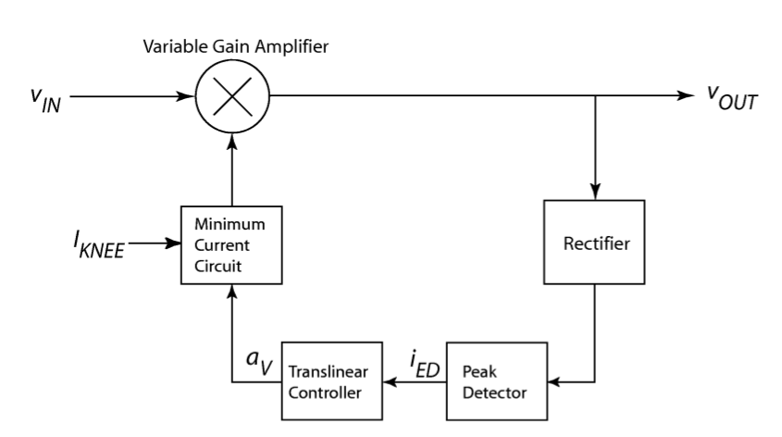
Figure 6.1

